Lab Exercise – 5

Harsh Vardhan Kushwaha

17BCN7017

1. **Find the employee who is getting highest salary in dept research.**

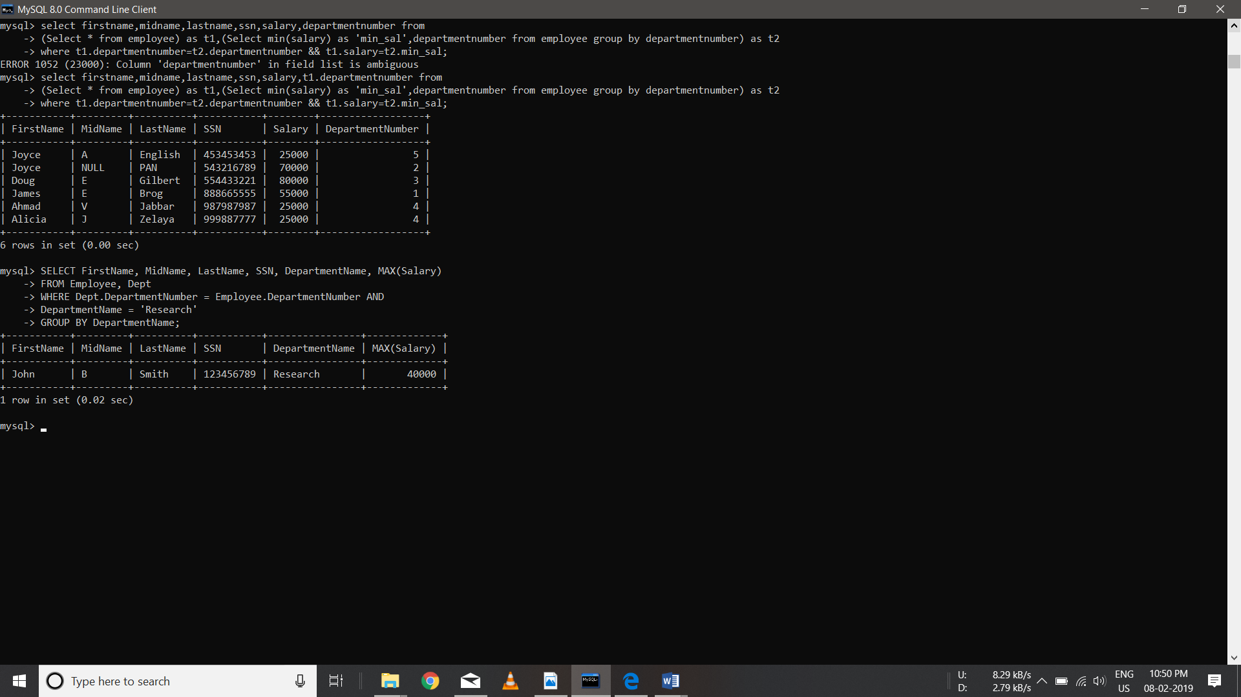

1. **Find the employee who earns the same salary as the minimum salary.**



1. **Find the employee whose salary is greater then the average salary of department 2.**

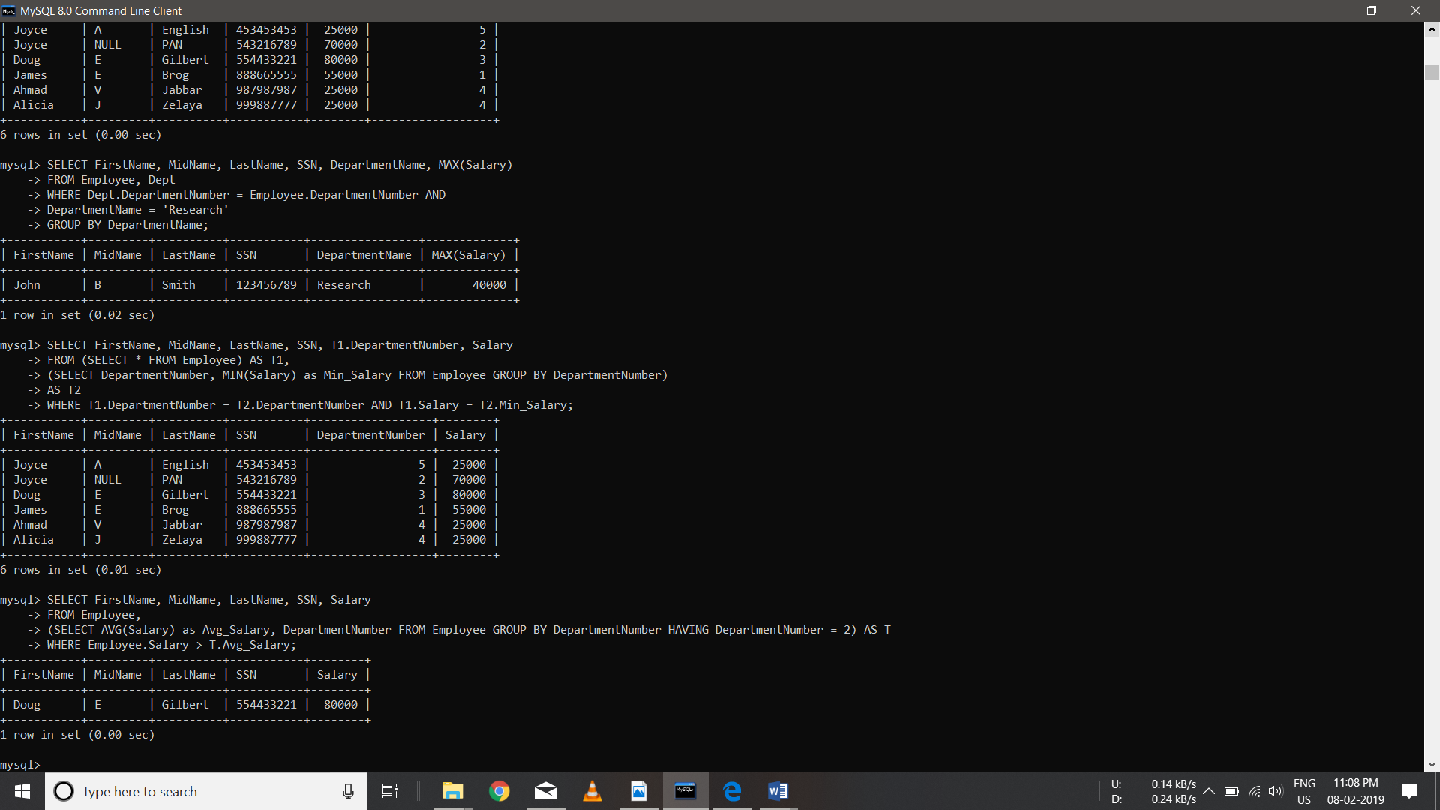

1. List out all the department names with their individual employee strength.



1. **Find out the department names with their individual employees strength.**



1. **List out all the departments and average salary drawn by their employees.**



1. **Find maximum average salary for each department.**

